DHIS 2 GIS
User Documentation

Administrator panel

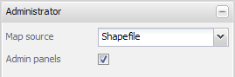
- Map source
Decides which way the application looks for maps.
Shapefile: you will find your own registered maps in the Map combobox in the Thematic map panel. The shapefile management panels will become visibile.
DHIS Database: the Map combobox will simply be populated by the existing organisation unit levels and shapefiles will be created by the application on the fly. Organisation units must have coordinates stored in the datasbase in order to be displayed in the map. This function is mainly intended for the facility level as it is easy to maintain and thus will offer up-to-date shapefiles.

Register maps

Register a shapefile by filling out this form:
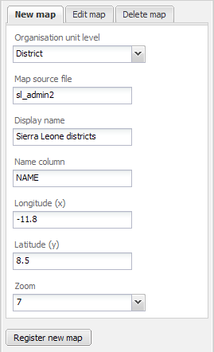
- Organisation unit level
The level of the organisation units displayed in the shapefile.
- Map source file
The GeoJSON file name.
- Display name
Represents your map in the Map combo box in the Thematic map panel.
- Name column
The shapefile data column (case sensitive!) that will be matched against DHIS organisation unit names. There are several ways to get it, eg. Geoserver:
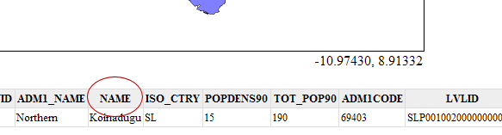
By opening the .dbf file:
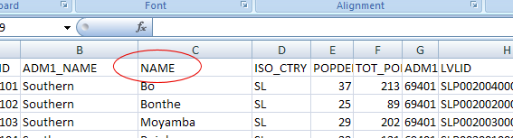
Directly from the GeoJSON file etc:
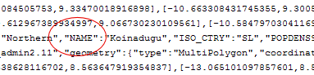

- Longitude / latitude
Get them from eg. Geoserver or the GIS application background map, put the mouse in the center of the country and note the coordinates. One decimal is sufficient, i.e. in this case -11.8 and 8.5:
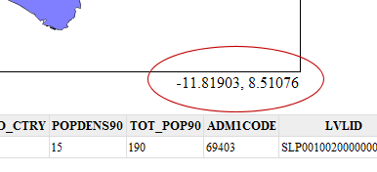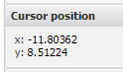
- Zoom
Depends on the shapefile. 7 is usually a good choice for countries.
Assign organisation units to map
Select a registered map and wait for it to load. The organisation units (OU) in your database on this level will appear in the list and colors will appear in the map. What we want to do here is creating relations between OUs in the database and the corresponding OUs in the shapefile. First, try auto-assign at the bottom toolbar to let the application link the OUs with a matching OU name in the shapefile. The polygons that remain white, you will have to link manually by first selecting a white OU in the list and then click the corresponding OU in the map.
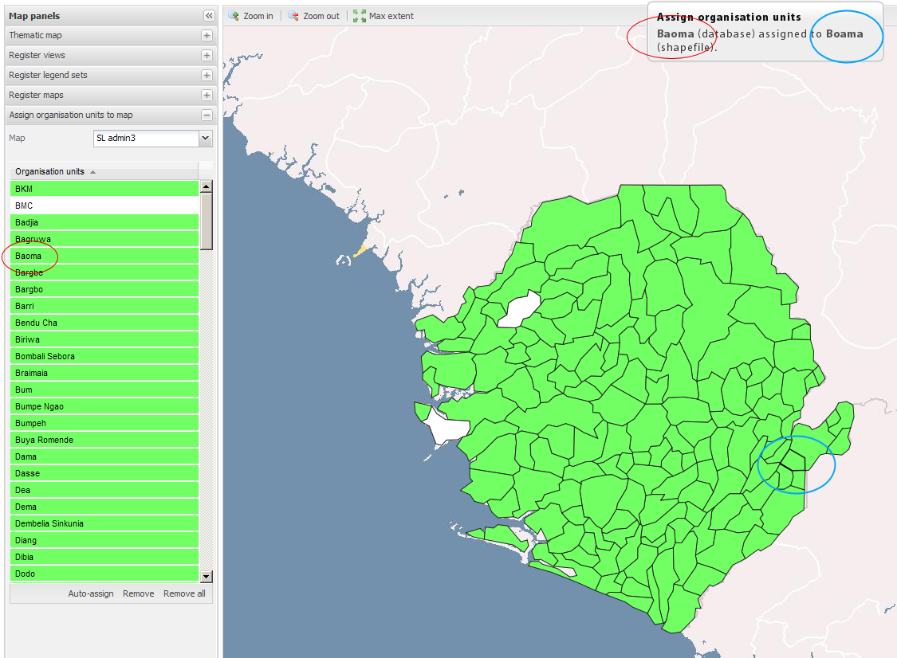
The remove button at the botton toolbar removes the selected OU’s link. The remove all button removes all OU links for the selected map.

Register overlays

- Display name
Represents your overlay in the layer tree in the upper right corner.
- Map source file
The GeoJSON file name.
- Fill color
Decides the fill color if the overlay has polygons.
- Fill opacity
Select an opacity level between 0 (invicible) and 1 (solid).
- Stroke color
The stroke color over lines and polygon borders.
- Stroke width
Select a stroke width between 0 and 4.

Thematic map

This panel should be rather self-explanatory . Calculation method alludes to the legend interval size and set to Equal intervals they will be “highest map value – lowest map value / number of classes”. Choose Fixed bounds and you may set your own legend limits, e.g. “20,40,60”. The classes box decides the number of intervals.

Register views
Saving the current thematic map view in order to restore it whenever you want via the Map view combo box in the Thematic map panel. By adding your views to DHIS 2 Dashboard you may access them there by inserting “Map views” into one of link areas.

Register legend sets

A legend set may be connected to many indicators, but an indicator may only have one legend set. Thus, you may select many indicators when you create a legend set. When an indicator that has a legend set is selected in the Thematic map panel, the number of classes, low color and high color is automaticly set.

